ASSIGNMENT 9
AWS Educate and Amazon EC2: An IaaS Experience for Data Analysis
Data Science and Cloud Computing in Bioinformatics
1. Introduction
Cloud computing gives users on-demand access to computing power, storage, and networking over the internet, so they don’t need to buy and maintain physical hardware. Infrastructure as a Service (IaaS) is the cloud model in which a user rents virtualized infrastructure and controls how it is configured. Amazon Elastic Compute Cloud (Amazon EC2) is Amazon Web Services’ main IaaS offering. It lets users launch virtual servers, choose an operating system, control network access, and scale resources up or down as needed. This is useful for data analysis and bioinformatics, where workloads range from small sequence-statistics scripts to large genome-assembly jobs that need far more CPU and memory.
2. Objective
The objective of this activity was to gain practical experience with a cloud platform by registering with AWS Educate and using its EC2 learning environment. I wanted to understand how an IaaS virtual server is accessed and managed securely, and how this kind of infrastructure could support data-analysis workloads in bioinformatics.
3. Platform and Registration
I used AWS Educate, Amazon’s free learning platform for building cloud skills. It offers guided courses and labs, so learners can practice cloud skills without building their own infrastructure.
Figure 1. The AWS Educate landing page, with the “Register now” and “Sign in to AWS Educate” options.
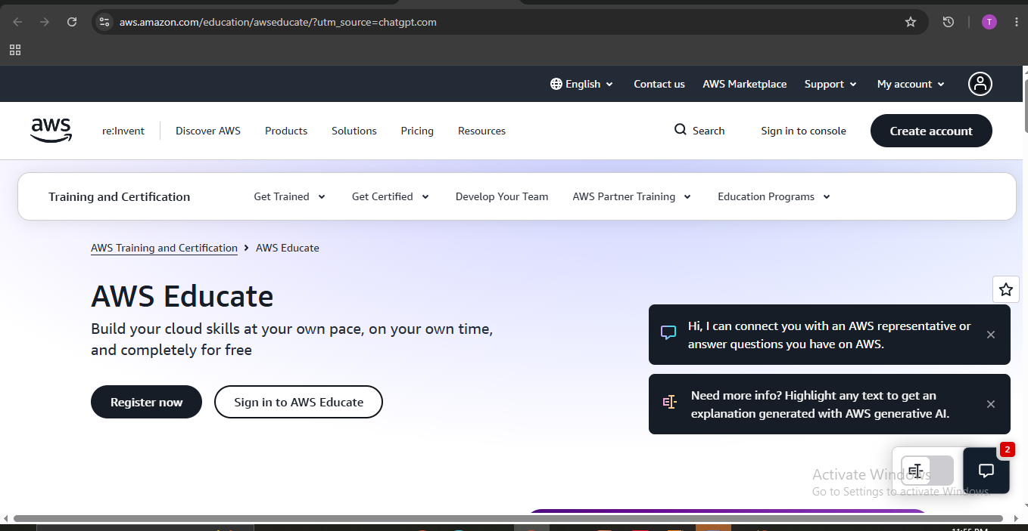
Figure 2. The AWS Educate dashboard after signing in. the dashboard after I signed in. It includes a “Courses & labs” section with a keyword search and filters for course features, skills, level, duration, and language. The “Getting Started” section is aimed at learners who are new to cloud computing. The filters and search made it easy to find a course on EC2.
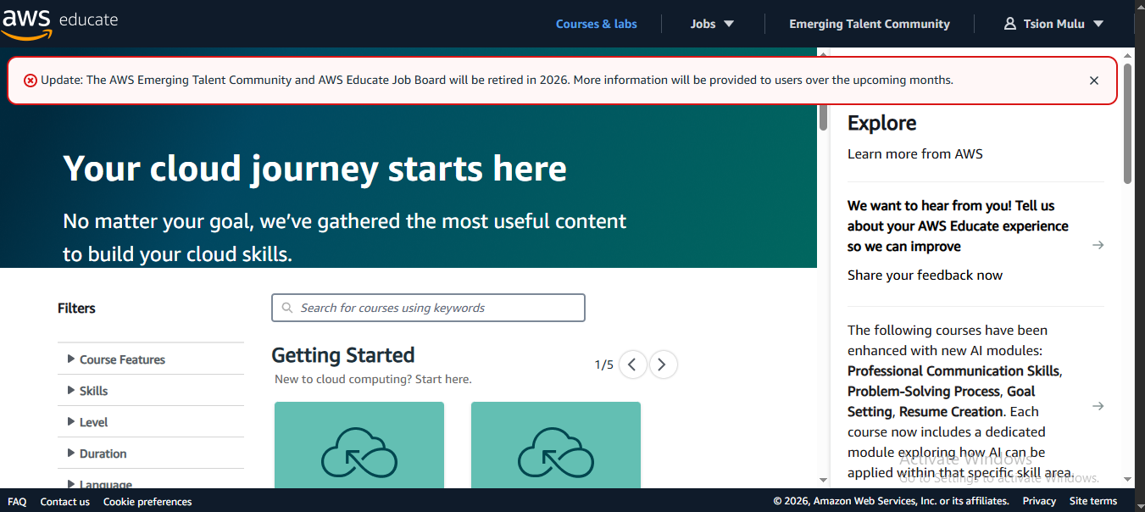
4. Selecting the EC2 Course
I chose the course “Logging into a Linux Instance Using Amazon EC2 Instance Connect” because it focuses on EC2, the IaaS service this assignment is about.
Figure 3. The course home page. It explains that EC2 Instance Connect is a simple and secure way to connect to Linux EC2 instances through the AWS Console. Instead of sharing and managing SSH keys, access is controlled with AWS Identity and Access Management (IAM) policies, and every connection request is logged in AWS CloudTrail so it can be audited. The course teaches how to log in to an instance, identify and change the required security permissions, verify the IP address, and update the instance’s operating system. It is labelled foundational level, written for beginners in cloud computing.
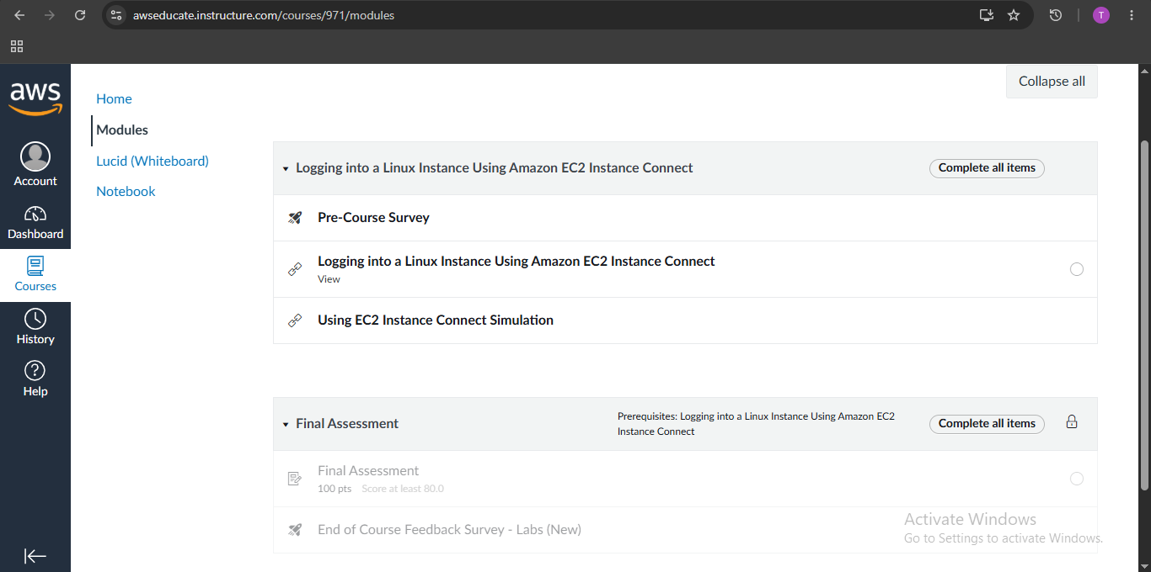
Figure 4 shows how the course is structured: a pre-course survey, the main lesson (“Logging into a Linux Instance Using Amazon EC2 Instance Connect”), a hands-on “Using EC2 Instance Connect Simulation”, and a Final Assessment worth 100 points that requires a score of at least 80. The assessment stays locked until the lesson is completed, so each stage has to be finished in order. A feedback survey comes at the end.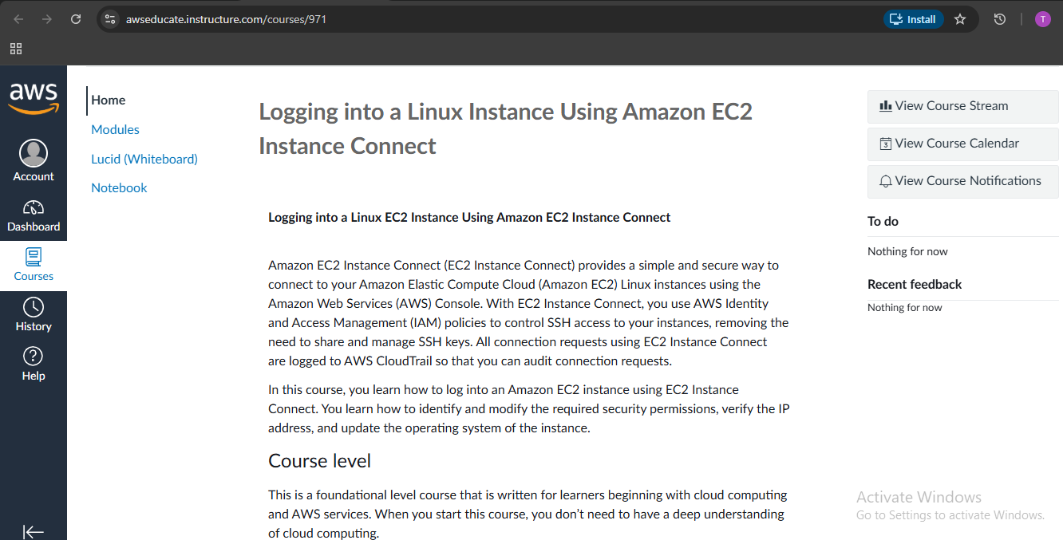
5. Course Content: Connecting to EC2
The main lesson is an interactive slide course with a menu of 12 sections: Welcome, Why Amazon EC2 Instance Connect?, Course objectives, Why you need to connect to an instance, Permissions, Explore using EC2 Instance Connect, Updating the security group, Connecting to EC2 Instance Connect, Running commands, Additional resources, Summary, and Thank you.
Figure 5. Lesson slide “Why Amazon EC2 Instance Connect?”an SSH connection from a user’s computer to an Amazon EC2 instance in the AWS cloud. This explains the core idea: the analyst works from their own machine, while the computation happens on a remote virtual server. For a bioinformatics researcher, that means heavy analyses can run on cloud hardware instead of a personal laptop.
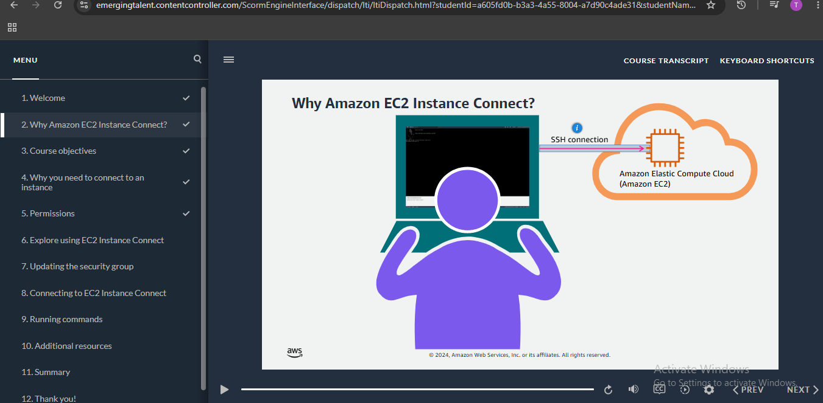
Figure 6 lists four ways to connect to a Linux instance: EC2 Instance Connect, Session Manager, an SSH client, and the EC2 serial console. Seeing the options side by side showed me that EC2 Instance Connect is the simplest for browser-based access. It needs no separate SSH client, and permissions are managed through IAM.
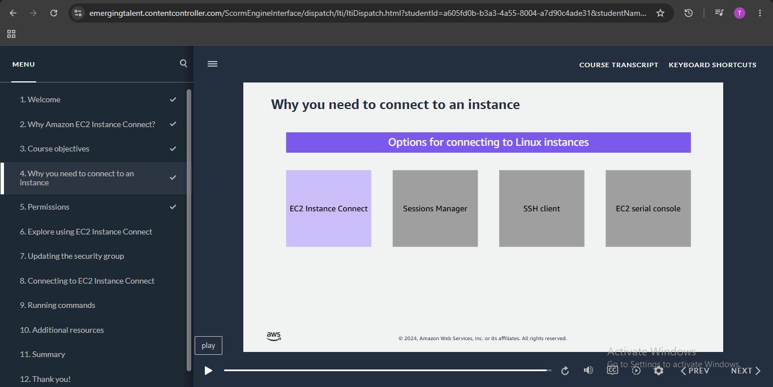
Figure 7 shows how access is controlled. An IAM policy sits between the user’s connection (EC2 Instance Connect) and the Amazon EC2 instance. A user can only connect if the policy explicitly allows it. This showed me that cloud access is governed by identity-based rules, not just by owning a password or key, which matters when sensitive research data is stored on a server.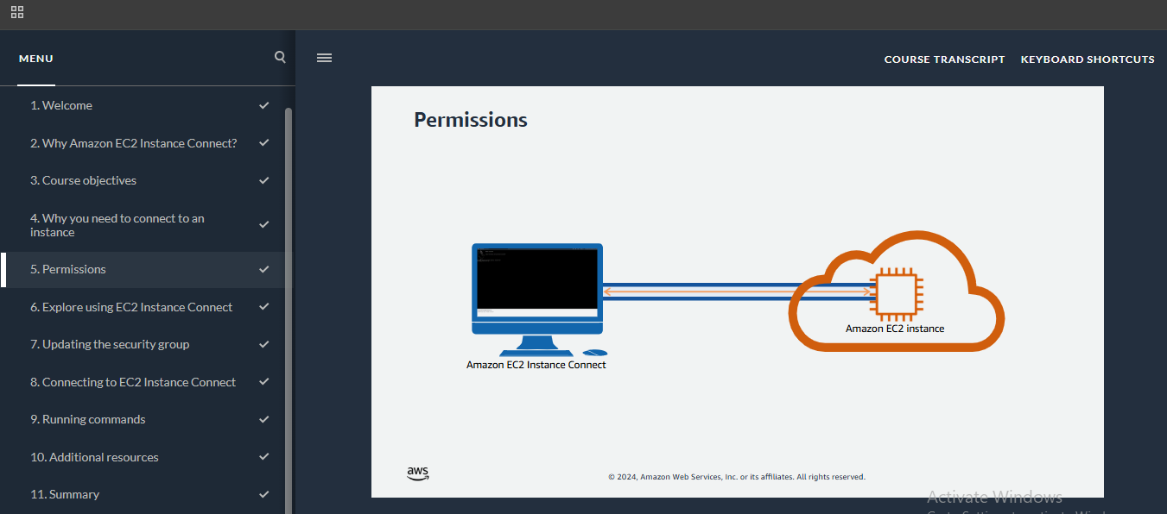
6. Exploring the EC2 Console
Figure 8. The EC2 dashboard shown in the “Explore using EC2 Instance Connect” section. shows the EC2 dashboard in the US East (N. Virginia) region. The Resources panel summarizes what exists in the account: running instances, key pairs, security groups, volumes, snapshots, load balancers, and so on. The left menu groups features into categories such as Instances, Images, Elastic Block Store, and Network & Security. An arrow in the lesson points to “Instances,” the page where servers are listed and managed. The dashboard shows that EC2 is more than a single virtual machine. It is a set of connected components: compute, storage volumes, networking, and access control.

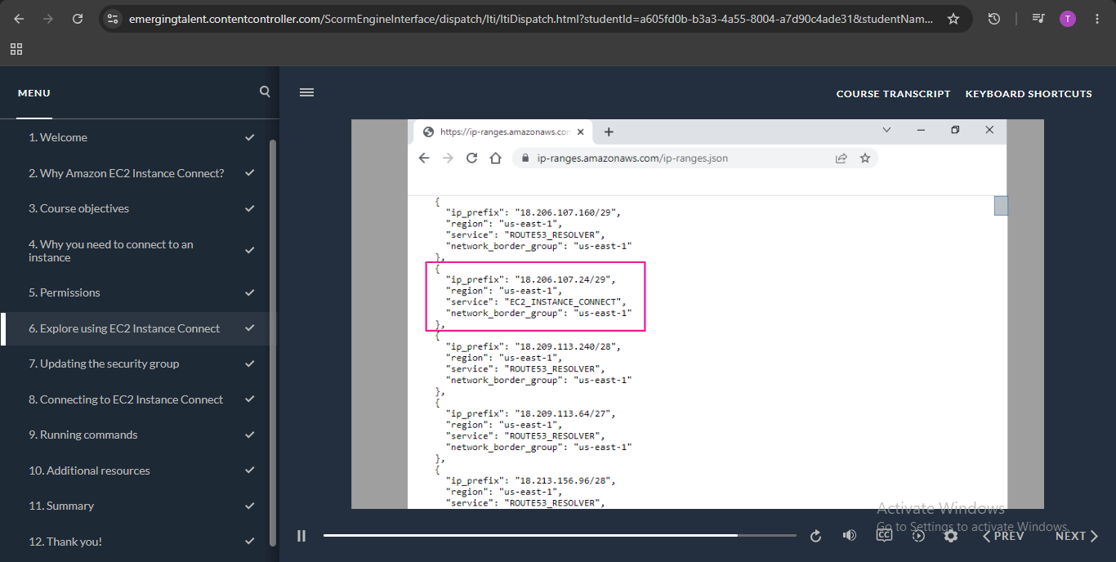
7. Updating the Security Group
Figure 9. Security group details and inbound rules in the “Updating the security group” section shows a security group named “Dev security group” with the description “Security group for developers.” Its inbound rules tab lists a rule that allows SSH over TCP on port 22 using IPv4. A security group works as a virtual firewall for an instance, deciding which traffic may reach it. To use EC2 Instance Connect, the instance’s security group must allow SSH from the right source. The lesson showed how to view and edit these inbound rules. Restricting access to the required port and source, instead of leaving the server open to everyone, reduces the risk of unauthorized access.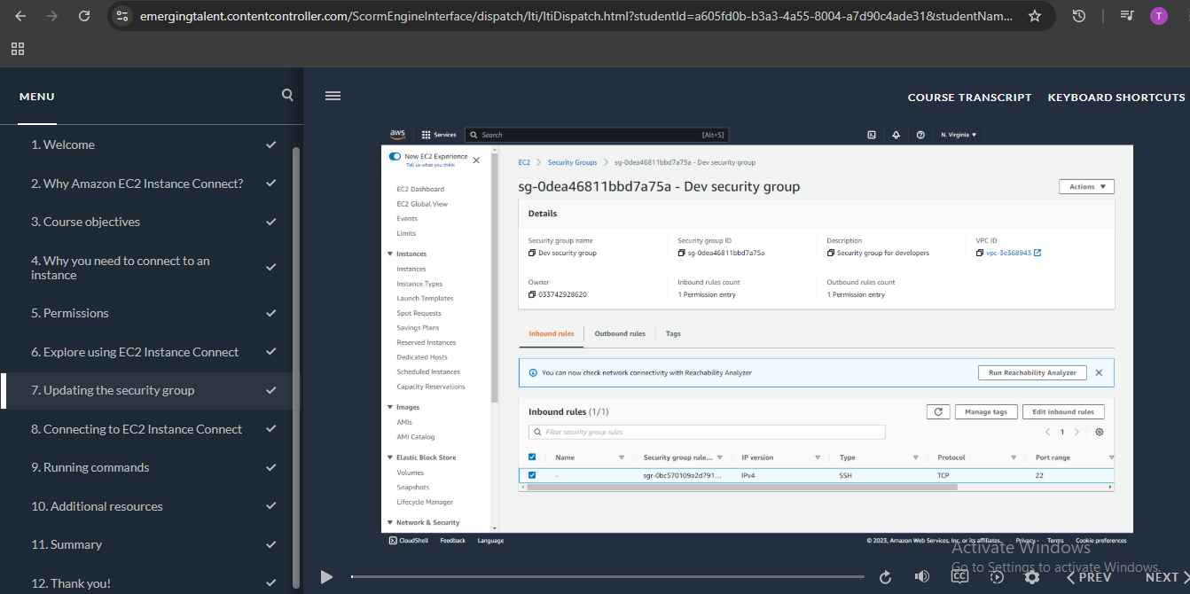
8. Connecting to an Instance
Figure 10. The Instances list in the “Connecting to EC2 Instance Connect” section. shows two instances, “DEV Server” and “Web Server.” Both are in the Running state, use the t2.micro type, passed 2/2 status checks, and run in different availability zones (us-east-1d and us-east-1c). The lesson highlights the Connect button, which becomes active once an instance is selected. The status checks and instance state confirm that a server is healthy before anyone logs in. Connecting through the Connect button opens a terminal in the browser, so no separate SSH software is needed.

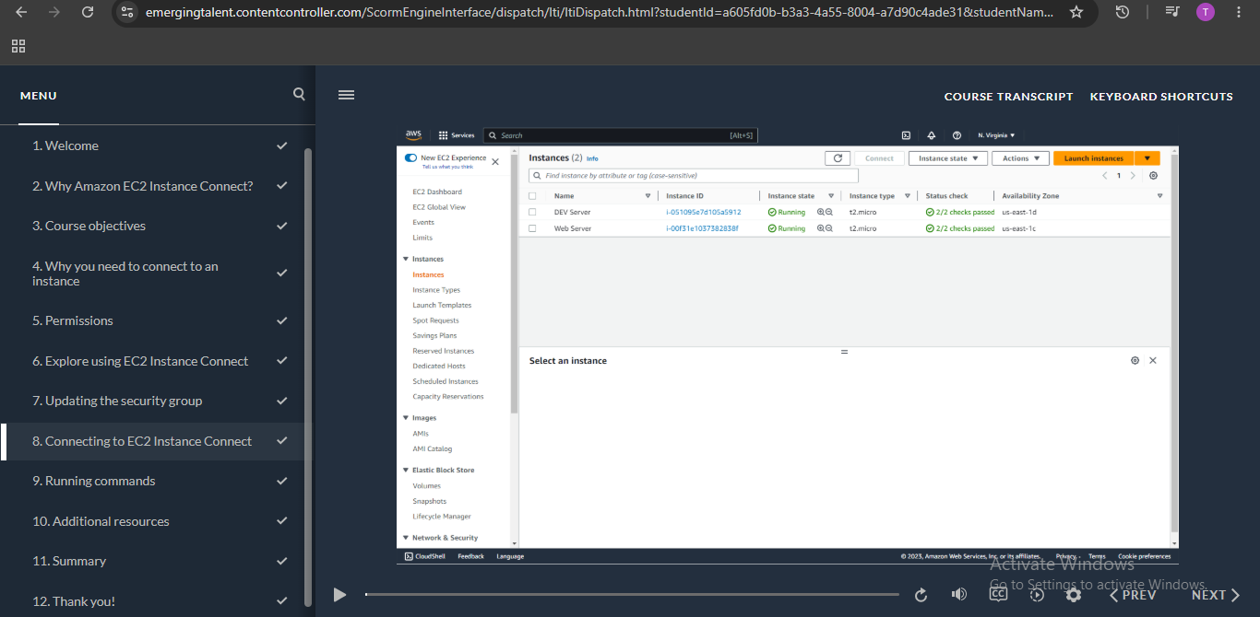
9. Running Commands
Figure 11. Terminal session on the DEV Server running a system update.shows a browser-based terminal connected to the DEV Server, with the prompt ec2-user@ip-172-31-26-104. The command run was: sudo yum update –y
The lesson explained each part:
- sudo gives temporary administrator rights for administrative tasks.
- yum update searches for and installs system updates using the yum package manager.
- -y automatically answers “yes” to confirmation prompts.

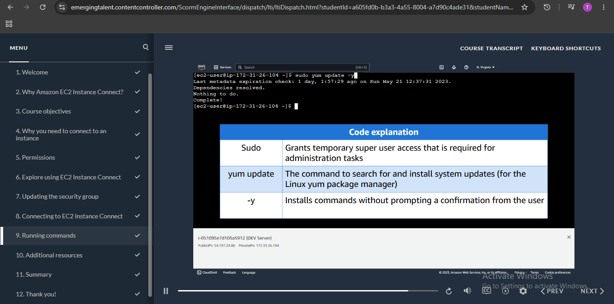

10. Additional Resources and Summary
Figure 12. Lesson slide “Additional resources.” lists further reading: AWS IP Ranges, connecting to a Linux instance with EC2 Instance Connect, granting IAM permissions for EC2 Instance Connect, and connecting using EC2 Instance Connect. These resources support deeper study beyond the course.
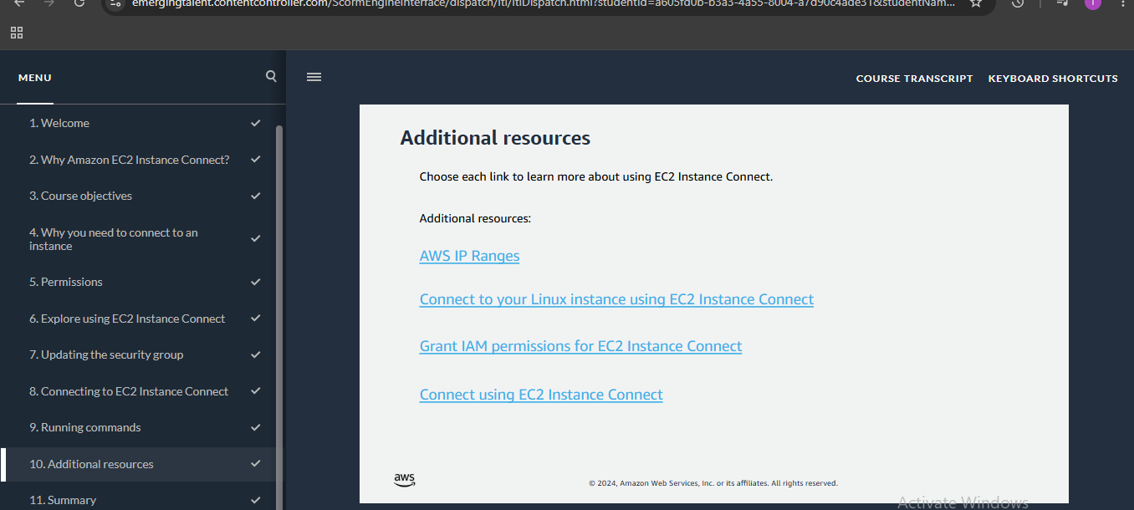
Figure 13. Lesson slide “Summary.”
Figure 13 summarizes the six skills covered in the course: why you must log into an EC2 instance, the different ways of logging in, the permissions required, how to modify a security group for EC2 Instance Connect, how to connect to an instance, and how to run commands. The slide also says the next step is the hands-on “Using Amazon EC2 Instance Connect” simulation.
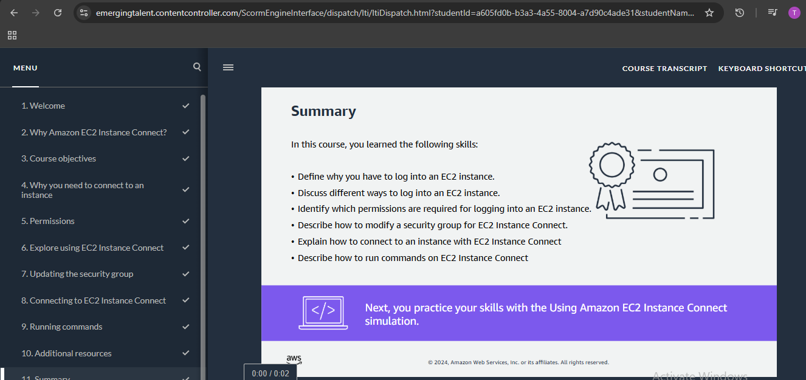

11. EC2 as IaaS for Bioinformatics and Data Analysis
Infrastructure as a Service (IaaS) allows researchers to access computing resources without purchasing and maintaining physical servers. Amazon Elastic Compute Cloud (EC2) is an example of IaaS that provides virtual machines, known as instances, through the cloud. Users can select an operating system, configure computing capacity, attach storage, and manage access to their instances according to their requirements.
This is particularly useful in bioinformatics, where computational requirements vary depending on the type and size of the analysis. For example, calculating GC content from a small DNA sequence requires relatively few resources, whereas genome assembly, metagenomic analysis, and variant calling may require substantial CPU power, memory, and storage. EC2 allows researchers to select suitable instance types and adjust resources according to their workloads. This provides flexibility and reduces the need to maintain expensive computing infrastructure locally.

12. Proposed Application to a Bioinformatics Workflow
The knowledge gained from the AWS Educate lesson can be applied to a typical bioinformatics workflow using a Linux-based EC2 instance. A possible workflow would involve the following steps:
- Connect to the EC2 instance: Establish a secure connection to the Linux virtual machine using EC2 Instance Connect.
- Prepare the environment: Update the operating system and install bioinformatics tools such as Python, Biopython, and FastQC.
- Upload biological data: Transfer sequencing data in FASTA or FASTQ format to the instance.
- Perform quality control: Use FastQC to assess sequencing quality and identify potential problems in the data.
- Conduct data analysis: Perform downstream analyses such as sequence alignment, genome assembly, annotation, or statistical analysis.
- Store the results: Save the processed data and analysis outputs in attached storage or an appropriate cloud storage service.
- Manage computing resources: Adjust the instance specifications when additional CPU or memory is required and stop or terminate unused resources to avoid unnecessary costs.
This workflow demonstrates how EC2 can support computational biology and bioinformatics research. It represents a proposed application of the concepts learned rather than an independently completed bioinformatics experiment.

13. Experience and Reflection
The AWS Educate lesson, Logging into a Linux Instance Using Amazon EC2 Instance Connect, introduced me to the practical aspects of accessing and managing a cloud-based Linux environment.
Before studying this topic, I mainly understood a cloud server as a remote computer that could be accessed through the internet. However, the lesson helped me understand that cloud computing involves several important components, including access permissions, network security, connection methods, and instance management.
One important concept I learned was the distinction between IAM permissions and security groups. IAM controls which users are authorized to perform actions on AWS resources, while security groups control the network traffic allowed to reach an EC2 instance. I also learned about EC2 Instance Connect, which provides a convenient browser-based method of accessing a Linux instance without requiring a separate SSH client.
As a Bioinformatics student, I found the flexibility of EC2 particularly relevant. Bioinformatics analyses can involve large datasets and computationally demanding processes that may exceed the capacity of a personal computer. Using cloud infrastructure makes it possible to access additional computing resources when needed without investing in a permanent high-performance workstation.
Overall, the activity helped me understand how IaaS can support scientific computing and how cloud-based Linux environments can be used for future bioinformatics and data-analysis projects.

14. Limitations of the Practical Activity
This report is based on the AWS Educate guided lesson, Logging into a Linux Instance Using Amazon EC2 Instance Connect. The screenshots included in the report document the instructional material and demonstrations provided through the lesson.
The practical activity focused on understanding the EC2 connection process, access permissions, security groups, and Linux instance access. However, I did not independently configure an EC2 instance or execute a bioinformatics analysis on a biological dataset. Therefore, the workflow described in Section 12 is a proposed application of the concepts learned and does not represent an experiment performed during this activity.

15. Conclusion
The AWS Educate lesson provided an introduction to Infrastructure as a Service (IaaS) and the use of Amazon EC2 for cloud-based computing. Through the lesson, I gained an understanding of Linux instance access, EC2 Instance Connect, IAM permissions, security groups, and the basic management of cloud computing resources.
The activity also helped me recognize the relevance of cloud computing to bioinformatics, particularly when working with large sequencing datasets and computationally intensive analyses. EC2 offers a flexible environment in which computing resources can be selected and adjusted according to the requirements of a particular task.
In conclusion, learning about AWS EC2 has strengthened my understanding of cloud infrastructure and provided useful foundational knowledge for applying cloud computing to future bioinformatics and data-analysis projects.

16. References
- Amazon Web Services. AWS Educate. https://aws.amazon.com/education/awseducate/
- Amazon Web Services. What is Infrastructure as a Service (IaaS)? https://aws.amazon.com/what-is/iaas/
- Amazon Web Services. What is Amazon EC2? Amazon EC2 User Guide. https://docs.aws.amazon.com/AWSEC2/latest/UserGuide/concepts.html
- Amazon Web Services. Connect to your Linux instance using EC2 Instance Connect. Amazon EC2 User Guide. https://docs.aws.amazon.com/AWSEC2/latest/UserGuide/connect-linux-inst-eic.html
